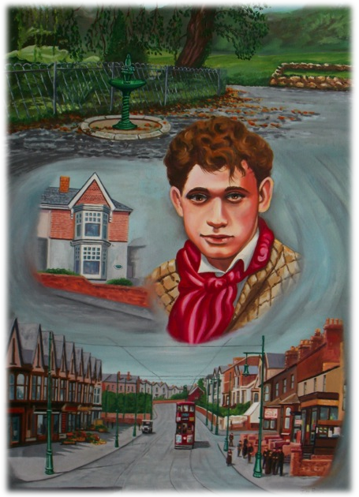
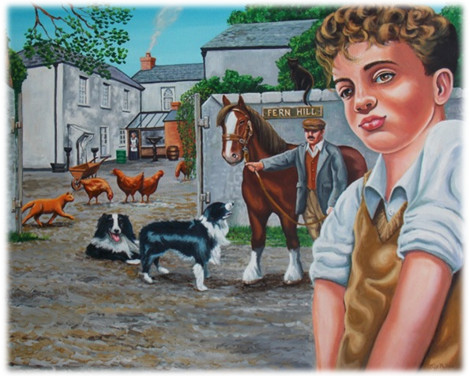
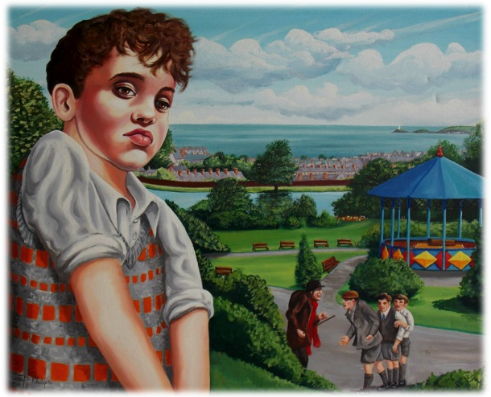
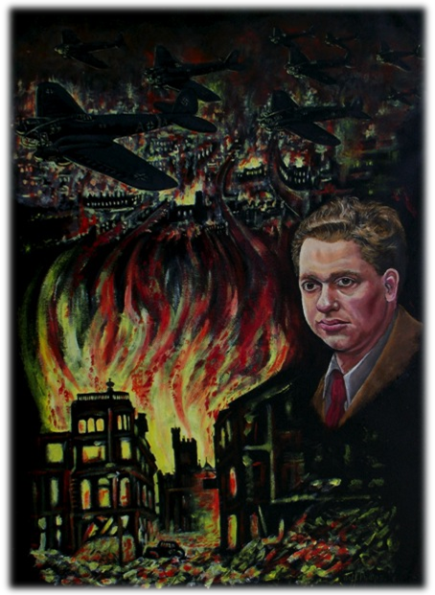

Teaching Ideas

- Watch the Jeff Phillips film clip. https://www.youtube.com/watch?v=4Fjt2iu4-EE

- Learners could take a different image per group and make notes around it.
What do you think he is trying to show in these images?
How accurate a representation are they of Dylan?
How are they effective?
Are the colours used important?
What emotions do you feel when you look at the image?
Why has Jeff Phillips chosen these things to draw? Why were they important to Dylan?

- As well as answering the questions above, learners could develop their own questions about the images. They could write the questions on post-it notes and place them around the image and then move onto another table, trying to think of new questions about the next image and so on. Learners could be encouraged to use question words other than ‘Why?’ to ensure a broad range of open, probing and maybe even philosophical questions.

- Depending on the quality of questions produced, a Philosophical Enquiry could then be facilitated by the teacher.

- Using quotes from Dylan’s work, and by reading the image, learners could match a picture to a quote.

